Tanweer Molla

December 6, 2012

Lab 5. Partner: Alex King, Josh Rood

Everett/Mahalov

**%Question 1**

x = [1:1:100]';

y = randn(size(x));

X = [ones(size(x)),x];

z = X'*y;

S = X'*X;

U = chol(S);

w = U'\z;

c = U\w

plot(x,y,'.','MarkerSize',10)

q = 1:0.1:100;

fit = c(1)+c(2)*q;

hold on

plot(q,fit,'r');

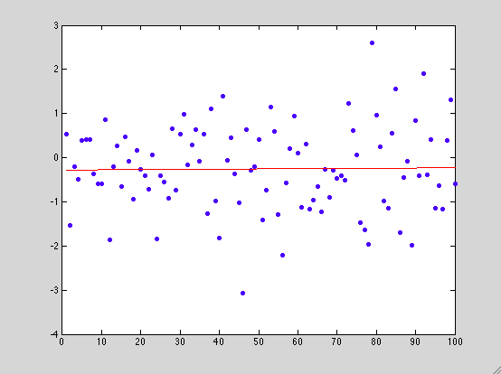

**c =**

**-2.7936e-01 🡪 slope**

**5.0300e-04 🡪 Y-intercept**

**%Equation is y= -2.7936*10^(-1)x+5.0300*10^(-4)**

**%1B**

**%Correlations that are presented in above composition are expected because of the uniform distribution of points. N in randn is size of x. the nxn matrix is Y**

**%Question 2**

dat = load('co2.dat');

year=dat(:,1);

conc=dat(:,2);

plot(year,conc,'o')

**%part A number 2**

X= [ones(size(year)),year];

z=X'*conc;

S=X'*X;

U=chol(S);

w=U'\z;

format short e

c=U\w

fit=c(1)+c(2)*year;

hold on

plot(year,fit,'k','linewidth',2)

axis tight

**%Part B number 2**

X=[ones(size(year)),year,year.^2];

z=X'*conc;

S=X'*X;

U=chol(S);

w=U'\z

c2=U\w

fit2=c2(1)+c2(2)*year+c2(3)*year.^2;

plot(year,fit2,'r','linewidth',2)

legend('data points','linear fit','quadratic fit',2)

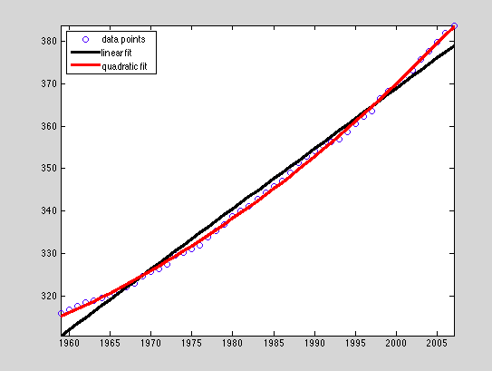

**c (PART A)=**

**-2.4718e+03 = C1**

**1.4204e+00 = C2**

w =

2.4137e+03

1.4061e+02

1.5018e+01

**c2 (PART B)=**

**4.4715e+04 = C1**

**-4.6174e+01 = C2**

**1.2000e-02 = C3**

**%Question 3**

format short e

dat = load('co2.dat');

x= [1;2;3;4;5;6;7;8;9;10];

y= [222;227;223;233;244;253;260;266;270;266];

hold on

X = [ones(size(x)),x,x.^2,x.^3];

z = X'*y;

S = X'*X;

U = chol(S);

w = U'\z;

c = U\w

plot(x,y,'.')

axis tight

q = 1:.1:10;

fit = c(1)+c(2)*q+c(3)*q.^2+c(4)*q.^3;

plot(q,fit,'k','linewidth',2);

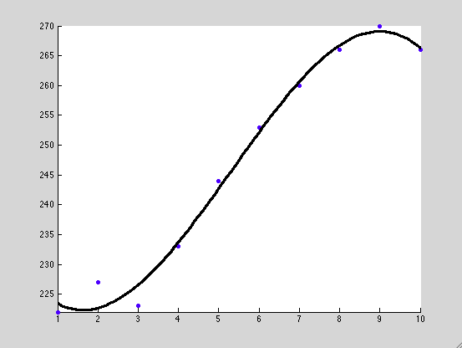

**%C Values for part A**

**c =**

**2.3023e+02 = C1**

**-1.0309e+01 = C2**

**3.7302e+00 = C3**

**-2.3388e-01 = C4**

**%PART B**

c2 = X\y

c2 = c2([4:-1:1]);

q2 = 1:.1:10;

z2 = polyval(c2,q2);

figure

plot(q2,z2,x,y,'o');

hold off

**%C Values for part B:**

**2.3023e+02 = C1**

**-1.0309e+01 = C2**

**3.7302e+00 = C3**

**-2.3388e-01 = C4**

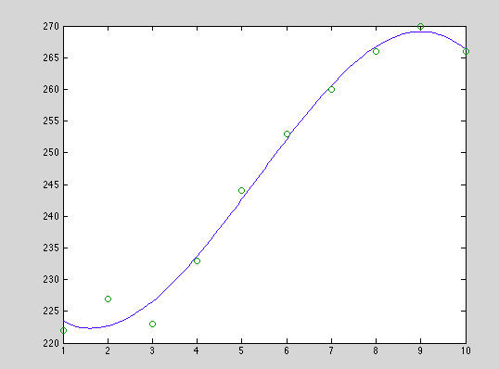

**Compared to Part A, the values of C are the exact same. Second graph gives identical data points as part A. When using the \ command, it was the exact same effect as the Cholesky decomposition.**